LAB FINAL EXAM

SUBITTED BY : FATIMA KASHIF
REG # 2023-BSE-018

Question # 01

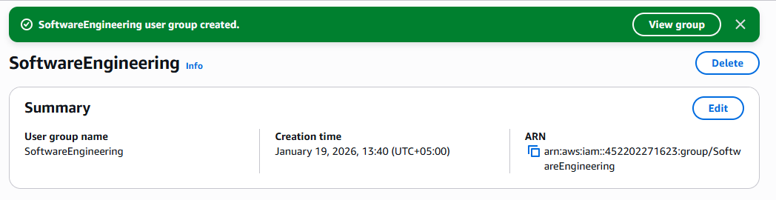
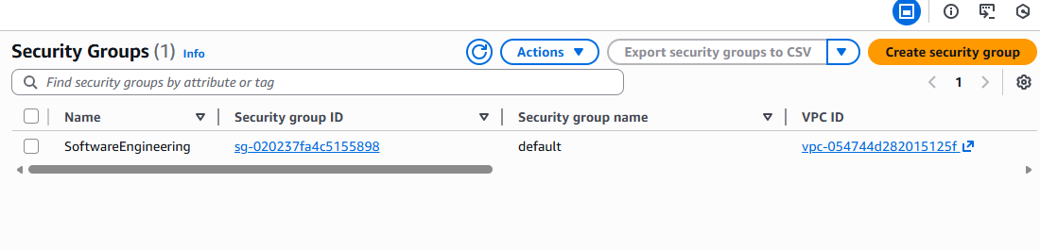
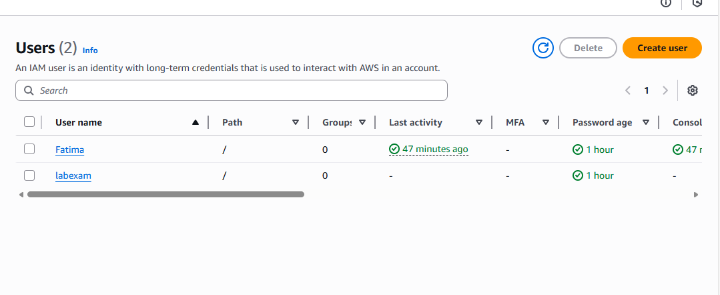

Question # 02
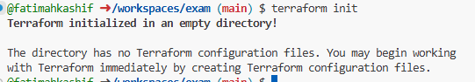
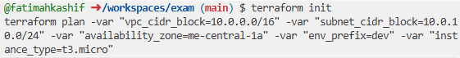

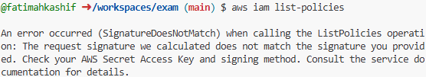

QUESTION # 02
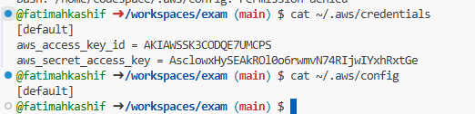

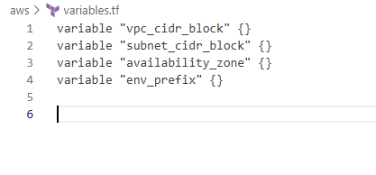
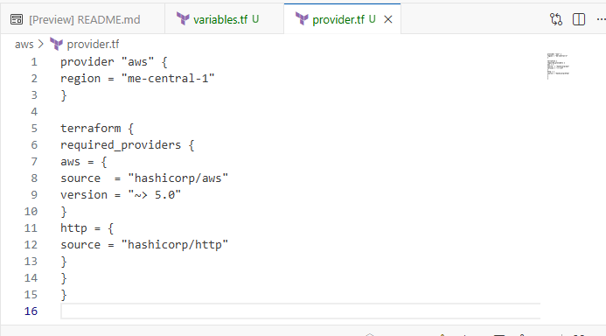
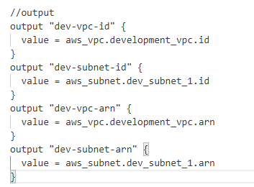

Question # 03

